Denis Project Architecture

PL Cosmo2SQL CosmoDB ---- > Azure Data Factory ---> Azure SQL Database

Denis Dim/FactSales Parallel PL Execution to Bronze layer

Looking up content in Geography table in CosmosDB

Execute PL Run for Data Ingestion from Multiple sources

Copy Data Activity with multiple source data to Bronze Layer

Ingesting SalesFact into Medallian Bronze layer

Ingesting multiple Dim data to Bronze layer

PL Bronze to Silver

Category Dataflow Transformations

SubCategory Dataflow Transformations

SalesRep Dataflow Transformations

Product Dataflow Transformations

Geography Dataflow Transformations

Grouping all the Dataflow activities into one PL Bronze2Silver_PL

Bronze2Silver PL Execution

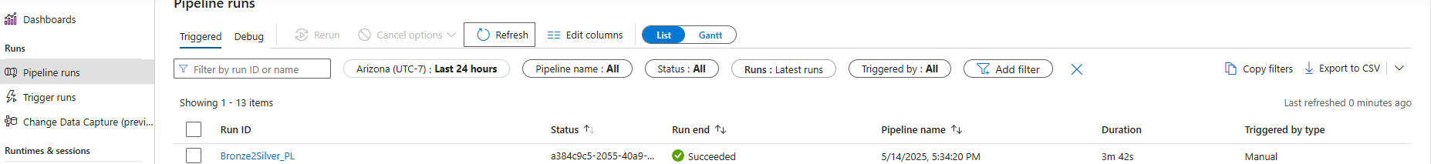

Silver Layer Data Cleaning with Ingested Files from Bronze Layer

Bronze2Silver_PL in progress

Bronze2Silver_PL completion

Renaming all ingested data sources from Bronze layer (ADF Generated file names) to match the sources data

Bronze2Silver_PL Execution based on all Dimensions datasets completion

Bronze2Silver_PL in progress

Bronze2Silver_PL Runs Completion

SalesFact Data Ingestion into Silver layer

Running the Parent Denis_PL, which call all the child Pipelines

Denis_PL Sequential Execute Pipeline Activity

Denis_PL (Main Pipeline #1) Execution Completion For Bronze and Bronze2Silver Pipelines

Denis Dim/FactSales Complex Transformation using Dataflow Activities

Silver2Gold_PL Execution Complete & Main Pipelines🡪 Denis_PL

All Denis Individual PL and Main PL Runs

1st Target Gold Layer containing curated and ready data

2nd Target Azure SQL_DB Containing all dimensions and fact table

Return a report on total Gross profit

Visualization of Total Revenue by Product and Total Revenue by Location

Visualization of Total Revenue by Product and Total Revenue by Location & SUM of

Gross Profit, Total Cost and Total Discount

